Darmita Wilson
02/09/2021
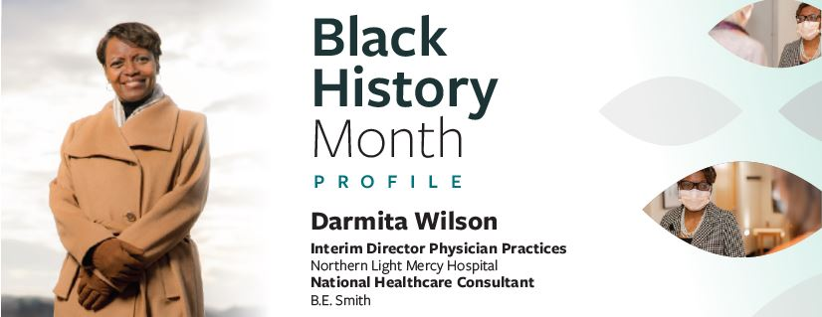

When Darmita Wilson thinks about the path that led her to a career in healthcare, she credits not only the people in her life but also the places she lived. She grew up Gary, Indiana by way of Mobile, Alabama, and as a young child remembers visiting her grandmother, who taught her how to be safe in public during segregation. “Even before I knew how to read, I remember my grandmother teaching me about the “w” and the “c” because when we were out at a public place, she didn’t want me to make the mistake of drinking out of a white (w) instead of a colored (c) water fountain.” Her mother and grandmother were active participants in the Civil Rights Movement, and her grandmother was on the Edmund Pettus Bridge during the Selma to Montgomery March. Darmita is a graduate of Howard University and attended during the same time as our new Vice President, Kamala Harris. Howard, a historically black university (HBCU), is where Darmita says she learned about a life of service to others.
“Seeing Vice President Harris inaugurated meant so much to me and all the Howard University community and the country because we know our education, steeped in our service to others, gives us the tools to serve no matter the cost. Howard University teaches us that a life of service as seen by Howard examples is a higher purpose than those who would deter you from it. Having a life of purpose allows you to have a purpose for life.”
In August of 2021, Darmita accepted the position in the Northern Light Health System, as Vice President of the Medical Groups. This position allows her to serve in both urban and rural health care delivery areas. Darmita originally came to Northern Light as a national health care consultant from Washington, D.C. specializing in medical operations and logistics. This position allowed her to work in over 24 health systems across the United States in her 32-year career. A life-long learner, Darmita is presently working on her Doctorate in health care delivery with emphasis on special populations and health care disparities. She is the proud mother of three grown children and look forward to new adventures in Maine.

